Testing of python project

This document checks the functionality only if the code works as intended or not

This is the employee part checking

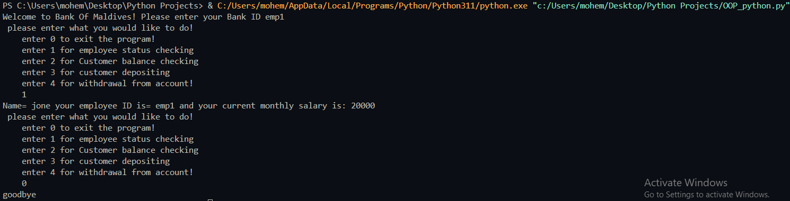

This is the customers function checking part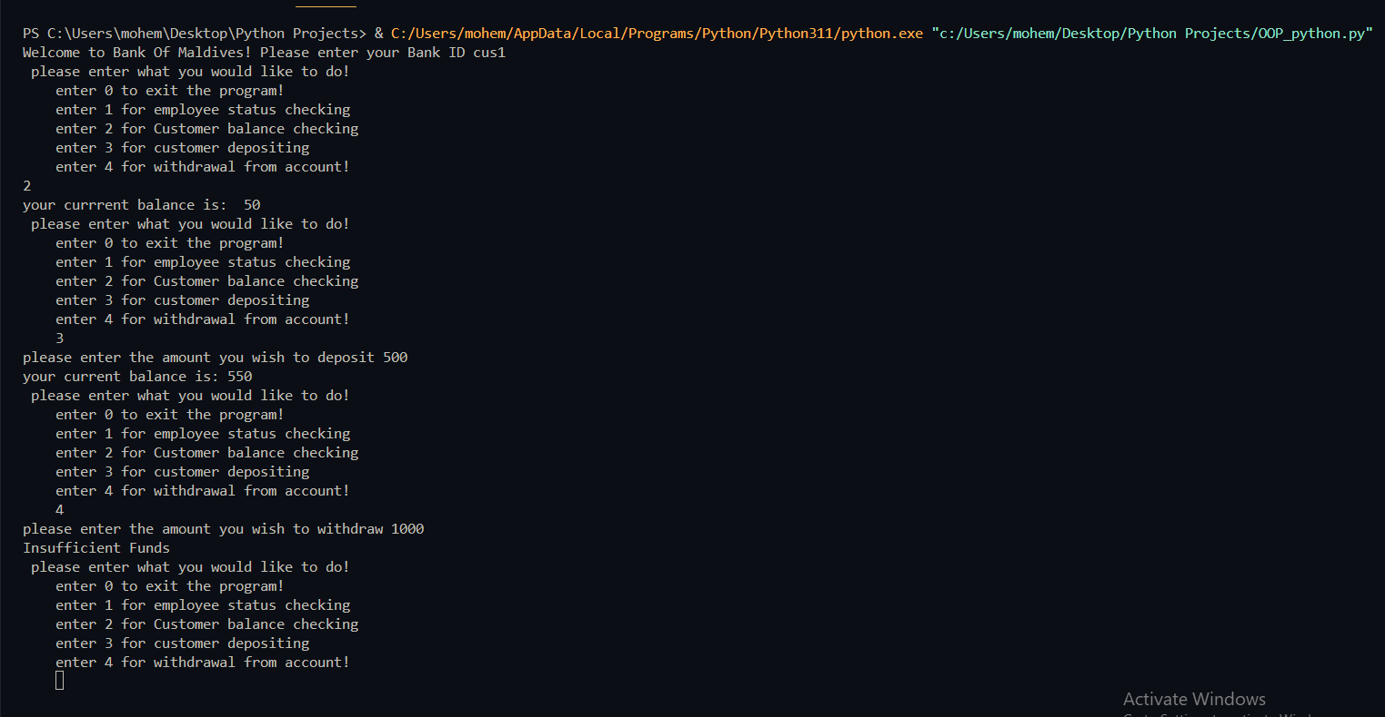

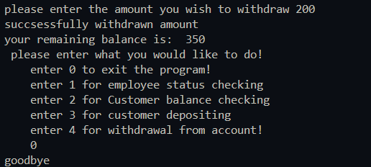

The 0 is for the exiting function

Conclusion: code works as expected!